**Problem 3 Computation are aligned with my calculations**

***# uniform distribution [0, 1]***

base <- seq(0, 1, 0.001)

length(base)

p.base <- rep(1/1001, 1001)

***# r.v. a1 and a2 with the uniform distribution***

a1 <- sample(base, size = 100000, prob = p.base, replace = T)

a2 <- sample(base, size = 100000, prob = p.base, replace = T)

***# create dataframe and create X, Y within the dataframe***

samples <- data.frame(a1, a2)

samples$x <- ifelse(samples$a1 > samples$a2, samples$a1, samples$a2)

samples$y <- ifelse(samples$a1 > samples$a2, samples$a2, samples$a1)

samples$xy <- samples$x * samples$y

plot(samples$x, samples$y)

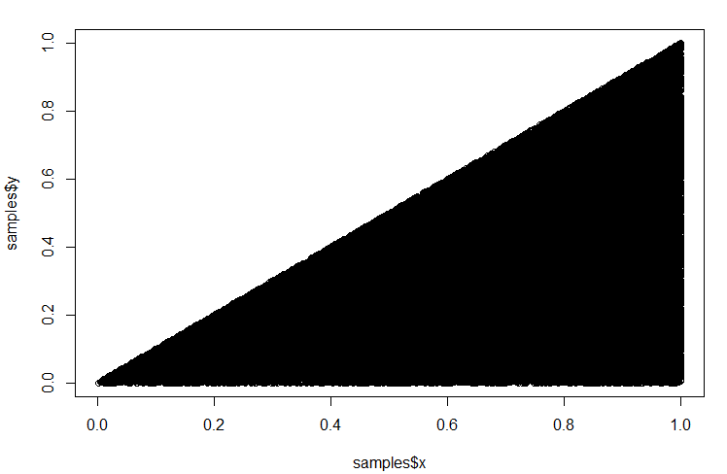

e.x <- mean(samples$x) # expectation of X = 0.6658

e.y <- mean(samples$y) # expectation of Y = 0.24954

e.xy <- mean(samples$xy) # expectation of XY = 0.3330

cov(samples$x, samples$y) # covariance(X, Y) = 0.02754959